Faculty Travel Grant Application Instructions for FluidReview

All faculty and faculty-sponsored student travel grant applications will go through the FluidReview platform, which can be accessed in two ways:

- Through the my.pomona.edu portal by clicking on Faculty and Student Conference Travel Grant;
- Directly through https://pomonacollege2.fluidreview.com/awds

In either case, you will need to be signed in with your regular username and password. If you are not signed in, you will be prompted to do so.

This will take you the “Awards” page where you will see two sections.

- Your Tasks, where you can set up your profile.
- Your Awards, where you will see all your pending applications.

Setting up your profile

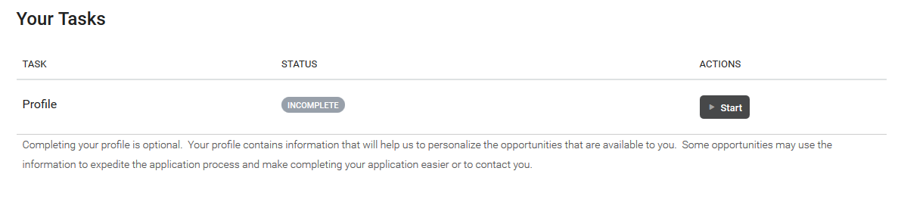
You have to option to set up a profile that will apply to all applications within FluidReview. This step is optional and is not required to start or complete a travel grant application.
Notice that the Status indicator is gray and reads “INCOMPLETE.” To set up a profile, click on the Start button under the Actions header.

On the Profile page, fill out any of the fields you want to and hit the green “Save & Exit” button at the end.

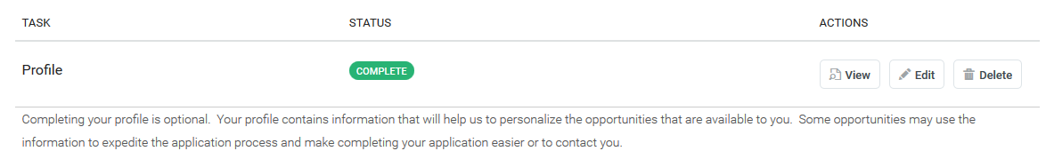
This should take you back to the Awards page. If you are taken to another page, you can return to the Awards page by clicking on “Jump to” on the top right of the page, and select “My Award Applications.”

The status of the profile task is now green and reads “COMPLETE’ and you have the options to view, edit or delete the profile.

Creating and viewing your travel grant application

When first using FluidReview, the Your Awards section of the page should not contain any information.

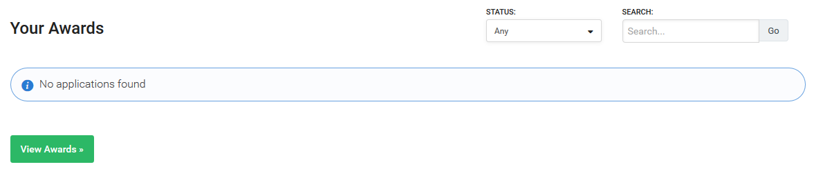
Once you start an application, even if not submitted, it will be listed under this section, and you can directly access it by clicking on the link.

In order to create a new application, click on the green “View Awards” button. On the next page you will find all Pomona internal grants applications that are administered using FluidReview, including the Faculty and Student Conference Travel Grant.

If you don’t have a pending travel grant application, you will see a green “Apply Now” button on the Faculty and Student Conference Travel Grant line. Click on it to start an application.
If you have started or submitted an application you won’t be able to start a second application and the green ‘Apply Now” button won’t be available until the pending application is withdrawn, approved or denied. Only one application can be submitted at a time.

By clicking on the “Apply Now” button, you are creating a new application. The next screen will be specific to your application, indicated by the title: your name, application to Faculty and Student Conference Travel Grant, and an application number.

The page indicates at which stage the application is and contains two sections:

- Application Round
- Activity

The Activity section will summarize which steps have been taken on the application.

The Application Round section identifies which application you are working on, what the status of the application is, and what actions are available.

In addition, it indicates whether the prerequisites for submission of the application have been met, and whether the application has been completed.

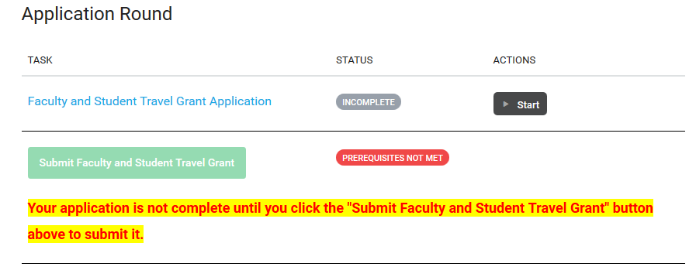

You will find two tasks: 1) the actual filling out of the application; and 2) submitting the completed application.

The Status indicator on the Faculty and Student Travel Grant Application will change to a green “COMPLETE” once the application forms are filled out. Once the status of the application changes to “COMPLETE,” the status of the Submit Faculty and Student Travel Grant task changes to a grey “INCOMPLETE,” and the green Submit faculty and Student Travel Grant button becomes active.

Click on the dark grey Start button to start filling out the application forms.

The first screen of the application summarizes the guidelines and requires your affirmation. Please read the guidelines, check the box and the end and click the green “Next” button.

The next screen gathers general data on the traveler and the conference. Fill out the fields, and click the green “Next” button. If you have missed a required field, you will be prompted to do so before you can go to the next application screen.

The next screen will ask for details about the travel budget, and whether any students will be presenting.

If students will present, please select “Yes” in that field, and then select the number of students. For each student, provide name, indicate whether the student is presenting, and provide the presentation title. Provide the amount requested for student travel costs.

Click the green “Next” button.

The final application screen will ask you to affirm that your department chair is informed about your travel plans and approves this application, and that you agree to submit the Travel Expense Report within 30 days of your return.

Select the check boxes, and if no further edits are required, click on the Green “Save & Exit button.
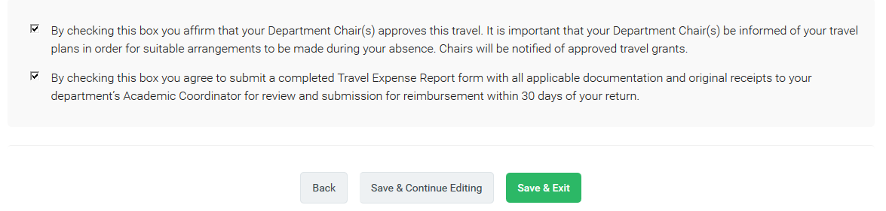

This will take you to the Application page and you will see that the application status will be changed to a green “COMPLETE,” and the Submit Faculty and Student Travel Grant button is now available.
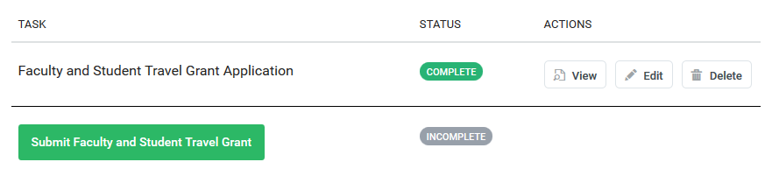

The application is not submitted until you click on the “Submit Faculty and Student Travel Grant” button. Once you do that, you will be asked to confirm the submission, and click the green “Continue” button.

You will set a confirmation page and a “Back to account” button that will take you to the Awards page.

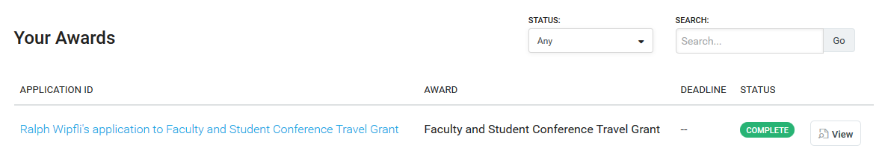
Your application will be listed under Your Awards with a “COMPLETE” status indicator. You can click on the View button to view, edit or download the application.

You may at any point click on the “Save & Continue Editing” button, or click “Back” to edit previous screens.

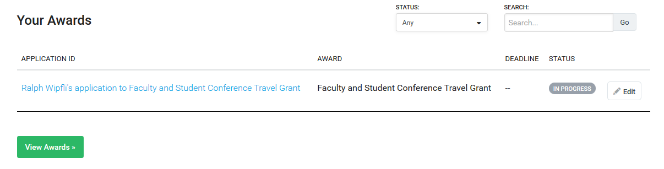
You may also leave FluidReview and come back later to finish the application. You will find the link to your applications in progress on the Awards screen under Your Awards with the status of “IN PROGRESS”:

You can edit the application by clicking on the Edit button, and then select “Continue” on the Application screen:

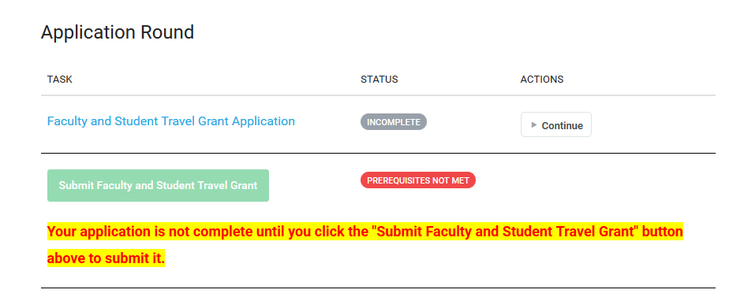

Once you have successfully submitted your application, the status fields for your Faculty and Student Travel Grants Application and the Submit Faculty and Student Travel Grant tasks will both be green and read “COMPLETE.”
