Workday How to Access Payslips

- Click on the Benefits and Pay application under Your Top Apps or View All Apps.

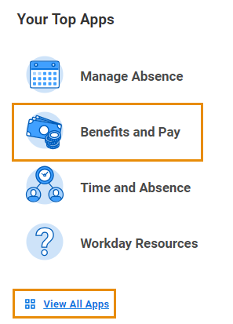

- Click on Pay > Payments and your Most Recent Pay, Deductions, All Payslips and Payment Elections will display.

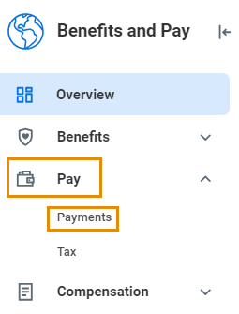

From the Payroll Hub – Worker Payments Information page you can view or print payslips under All Payslips, view your payment elections, compare pay periods, view pay history, view earnings/deductions history and model my pay.

