Payroll is using the excel time sheet instead of the green time sheets for late hours. This should only be used in emergencies. All hours should be entered in Workday by the deadline to avoid the use of manual time sheets. If you have an hourly employee, staff or student that has not entered their hours please notify them immediately.

**For Pomona Students & TCCS Students with multiple jobs- you must fill out1 time sheet per job.**

1. Fill out the top portion, NAME (please print), Workday Employee ID (can be found in Workday), Position Title, Pay Rate & Account Number if you have it.
2. Enter the start date of the pay period and the rest of the dates will populate in the time sheet.

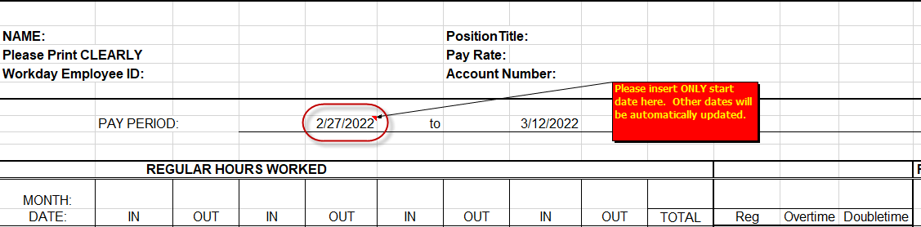

1. For in and out punches, enter ‘8 a’ and tab over and 8:00 AM will populate or enter ‘12 p’ and tab over and 12:00 PM will populate. There has to be a space between 8 and a.

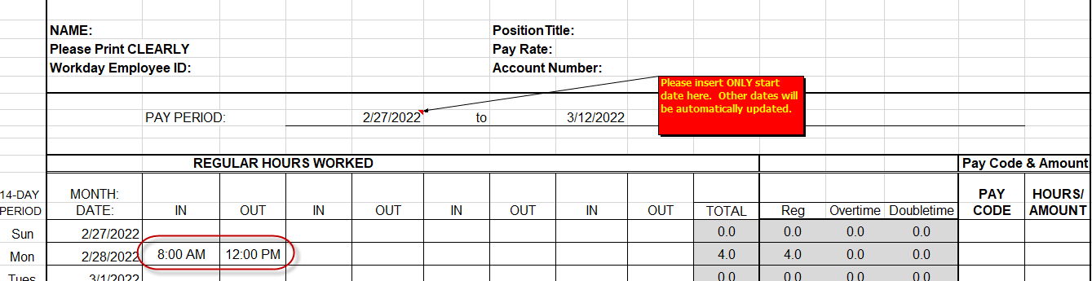

1. Once the in and out punches are entered the time sheet will do all the totals.

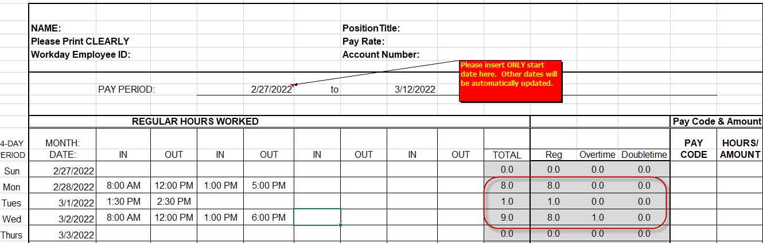

1. For time off i.e. VAC, SICK, PH, CA SICK for students or non-benefits eligible staff, select the pay code from the drop down and enter the number of hours taken.

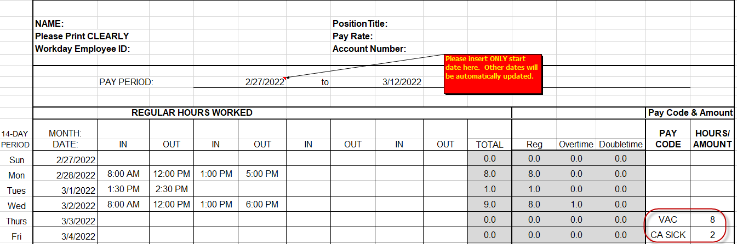

1. The excel time sheet will total all the columns at the bottom and the Total Hours.

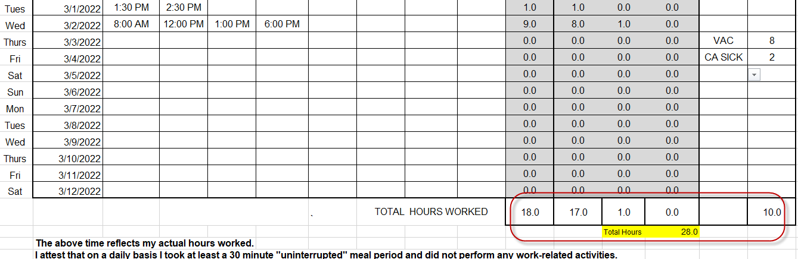

1. Approvals can be done digitally or you can print it, sign it and scan to your supervisor for their approval. Supervisors can sign digitally or print it, sign it and send to [payroll@pomona.edu](mailto:payroll@pomona.edu). Supervisors can also send an email with the completed time sheet attached stating you approve these hours.