1. Click on the **Benefits and** **Pay** application under **Your Top Apps** or **View All Apps**.

1. Click on **My Tax Documents**.

1. Click on **Edit**.

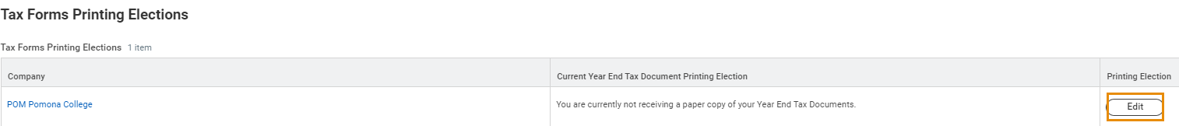

1. Select **Receive electronic copy of my Year End Tax Documents**.

1. Click on **OK**.

